|  |  |
| --- | --- |
| Sexual Violence in Washington DC  7/25/2019 | Abstract  This report analyzes the issue of sexual violence in Washington, DC by examining historical reports of sexual violence between 2008 and 2019 using data obtained from DC’s GIS Open Data portal. Hotspots were found in downtown DC and in area of Anacostia. 55.8% of sexual violence in DC occurred within a 1-mile radius of DC’s college campuses. Additionally, correlations between sexual violence and poverty, as well as race, were found. Finally, a reporting system was created to aid in the data collection and data standardization of sexual violence reports.  Natalie Morgan  John’s Hopkins University Geographic Information Systems Master’s Program Capstone |

Natalie Morgan

GIS Capstone

7/25/2019

Analysis of Sexual Violence in Washington DC

Washington, DC has a history of widespread crime. Beginning in the 1990s, crime became a serious issue for the city as the popularity of crack cocaine and the population of the city both began to rise. Overtime, Washington, DC has become a safer place to live and work. While occurring at a much lower rate than other violent crimes, sexual violence is still a serious issue for the city. Sexual violence overwhelmingly affects at-risk populations and does not get the attention or resources it deserves. This paper seeks to understand the issue of sexual violence in Washington, DC and will use the terms sexual violence, sexual assault, sexual abuse, and rape interchangeably.

**Statement of Problem**

The purpose of this project is to explore the nature of sexual violence, understand how GIS can be used to standardize data collection methods, discuss the need for a holistic customer relationship management platform, and perform analysis to identify historical trends of sexual violence in Washington, DC.

**Background**

Sexual Violence

Sexual Violence is a crime that is complicated by society expectations and taboos. Sexual violence can lead to increased “risk of future violence, sexual risk behaviors, and substance abuse disorders” in survivors. [1] The International Associations of Chiefs of Police (IACP) note that sexual violence “receives less attention and resources as other crimes due to the community misunderstanding and misperceptions about trauma and the realities of crime and perpetrators.” [2] There is a societal expectation that rape is committed by strangers. However, sexual violence is usually committed by people familiar with the victim [3] – this is the case for seven in ten accounts of rape. [4] Perhaps this expectation is solidified by low reporting rates. 77 percent of rapes by intimate partners and 61 percent of rapes by friends or acquaintances were not reported to the police, compared to 54 percent of rapes by strangers. [5] Overall, only 28 percent of rapes are reported to law enforcement. [6]

Sexual Violence and the Law/Reporting

Sexual violence often goes unreported due to fears of embarrassment, blame, and judgement. Victims often have additional fears of retaliation, police handling of the incident, and the stress of a trial. 23.3 percent of victims do not report to the police due to a personal matter, while 16.33 percent do not report out of fear of reprisal and 5.8 percent due to a fear of police bias. [7] Holly Johnson argues that these barriers have not improved.[8] Rape myths still persist in our community. There is a belief that women lie about rape to cover ulterior motives. A study in the United Kingdom found that 60% of law enforcement officers believed that women would lie about rape to dismiss guilt of having been caught having an affair, while 40% believed that many accusations of rape were made by women who wanted to have sex, but changed their mind after.[9] Even more concerning, the study found that 32% of law enforcement officers believed that women use claims of rape “as a way of getting back at men.” [10] The typical story arc of rape presented in our culture is one in which women are attacked by strangers and put up a strong physical fight. The realities of a victim’s psychological reaction to sexual violence varies. Johnson states that the majority of sexual assaults involve known men where resistance takes diverse and non-stereotypical forms depending on social and personal circumstances.”[11]

As a result, victims often feel pressure to report these crimes from a variety of sources. Victims feel obligated to report to the police to show that the assault was “real.” [12] Additionally, victims are expected to want to go to trial on these reports. In reality, the experience of a drawn-out trial can be as psychologically traumatic as the assault itself. When the victim doesn’t respond in the way that is expected, prosecutors may drop the case because they believe the probability of conviction to be too low. [13] Johnson found that less than half of the reports resulted in charges, less than half of those charges led to a prosecution, and a third of those prosecutions led to a conviction – resulting in an overall conviction rate of less than 1 percent. [14] The concept of credibility also plays a role in this low conviction rate. Johnson states that perceived credibility is “enhanced in cases involving strangers, white women, ethnic minority and low status perpetrators, a weapon, physical injuries, vigorous resistance, a recent complaint, emotional upset, forensic evidence, no prior complaints of sexual assault, and a sober respectable woman with no prior sexual relationship with the suspect and no history of psychiatric or intellectual impairment.”[15] These requirements become more complicated in situations involving perpetrators known to the victim. According to Johnson, the legal test for consent allows for men to have inherent claim to sex within the confines of marriage. [16]

At Risk Populations

Specific segments of the general population are at a higher risk of sexual violence. Women are at a higher risk of sexual violence than men. 25 percent of women will experience unwanted sexual contact in their lifetime, compared to 11% of men.[17] Additionally, populations that are already subject to general violence are also at a higher risk of sexual violence. [18] Finally, American Americans are at a higher risk of sexual violence comparted to their white counterparts.[19] A tool called Keys to Coping was developed to aid in the reporting of campus sexual violence, allowing victims to take photos of their own injuries and annotate on an image of the human anatomy. According to Dr. Penny Smith, the creator of Keys to Coping, this is especially impactful because injuries to women of color do not always show and are not collected as evidence. [20]

Data Collection on Sexual Violence

In their report to the US Senate Committee on Homeland Security and Governmental Affairs, the US Government Accountability Office (GAO) found overwhelming differences in how sexual assault data was being collected, thereby making law enforcement of sexual assault less effective and reportable. The GAO argued that this unstandardized method of data collection (particularly measurements and definitions) creates data confusion for both the police and for the general public attempting to conduct research with the datasets. [21] One of the issues they noted was the variation in the terms used to describe sexual violence. They found 23 different terms being used to include: rape, sexual assault, assault-sexual, nonconsensual sexual acts, sexual coercion, staff sexual misconduct, sexual violence involving vaginal penetration, penetrative sexual assault, and sexual assault with an object. [22] The National Intimate Partner and Sexual Violence Survey (NISVS) defines rape as: an act involving “the use of physical force or threats to physically harm the victim, while sexual coercion is defined as an act involving verbal pressure. [23] The GOA also found that the NISVS avoided the use of the word rape because they believed it carried a stigma or “would have different meanings to different people” and instead asked a multitude of questions regarding the exact physical acts so that they could use their own coding methods. [24] Finally, the GAO argued for better data collection for specific populations (university students, prison inmates, and members of the military) to get a better understanding on the effects on the population. [25]

GIS and Crime Analysis

Spencer Chainey et al., stated that, “crime does not occur randomly.” [26] Perpetrators are drawn to certain populations and certain locations for a reason. Perpetrators are drawn to crime generators and/or crime attractors. A crime generator is defined as “a particular area or node where large numbers of people are drawn for reasons that are not related to any particular criminal activity that they might commit.” [27] Examples of crime generators include: major sporting or concert arenas, or other large public spaces. A crime attractor is defined as “places which create criminal opportunities, and, in doing so attract motivated offenders to the neighborhood or suburb.” [28] An example of this includes areas known for crime such as drug or arms dealing and high risk areas for violent crime in general, where the person may reside or conduct their day-to-day activities. Crime generators and crime attractors support crime pattern theory which combines routine activity theory and rational choice theory, creating a relationship between the offence and the location in which it is conducted. [29] Chainey et al., uses the acronym CRAVED to describe reasons to commit property crimes. CRAVED stands for concealable, removeable, available valuable, enjoyable, and disposal. [30] This acronym can also be applied to sexual violence. When sexual violence is committed by perpetrators known to the victim in a private setting, the value of concealable can be obtained. When sexual violence is committed against a victim who has been taken to a second location, the value of removable is obtained. High-risk population can appear more available. Taking away a person’s right to their own body can appear valuable and enjoyable to a perpetrator. Finally, due to the low conviction rate for sexual violence, victims and the act can be viewed as disposable.

GIS as Evidence

GIS analyses and maps can be used as both scientific and demonstrative evidence in court. Scientific evidence is defined as “having probative value in and of itself, while demonstrative evidence is defined as “meant to clarify or illustrate testimony and has no probative value.” [31] Gregory Elmes et al., found that maps “signified authority and people trusted them unquestionably” as they had “no reason not to trust a map.” [32] This is despite the fact that, like charts or graphs, spatial data can be presented in a misleading way through maps depending on how the map was created and the intended message. Getting maps admitted as scientific evidence can be difficult as they require the testimony of an expert to explain the data and attest to its accuracy. [33] Maps are beneficial as demonstrative evidence as they can explain complex topics to a jury who have an 87 percent retention rate for visual evidence compared to a 10 percent retention rate for verbal evidence. [34] However, persuading law enforcement agencies to invest in GIS and set it up as a ystem in record can be difficult due to the planning involved and the learning curve for understanding the technology well enough to use it for analysis. [35]

Evaluation of Current Customer Relationship Management Platform

The Metropolitan Police Department (MPD) provides a customer relationship management (CRM) platform that provides the public with analyses of crime trends in Washington, DC. This “Crime Cards” website allows users to see crime totals and a high-level summary of crime trends. [36] This data is visualized through a crime map and several charts. A substantial “About” section explains the maps and graphs. Users can view crime over time, as well as, bar charts and pie charts by offense. Finally, Crime Cards provides contact information for MPD officials in each of the 8 DC wards.

While a great start, Metropolitan Police Department needs a better CRM platform. The analysis allowed by Crime Cards is very limited. The crime map displays preconstructed heat and point maps that can display data by ward, police sector, or census tract. Data cannot be overlaid with other layers and map functionality is limited to zoom in/out and zoom to user’s location. Users can change the analysis period from months to years – up to 8 years back (despite data being available through Open Data DC for the last eleven years). Crime data is separated by violent crime and property crime. However, specific types of crimes (such as sexual abuse) cannot be isolated. The webpage itself is not very user-friendly. There is a lot of information being presented at once it is difficult to get information beyond quick statistics. Additionally, the contact information for MPD is incorrect. The sixth ward is listed twice and the eight ward is missing.

According to the data in Crime Cards, sexual abuse between 2012 and 2018 has been low and has decreased over time. This is in line to data provided by Johnson who states that sexual violence reporting has decreased to 5 percent. [37] However, Johnson also argues that sexual assault has increased from 33 percent to 37 percent from 1999 to 2014. [38] It is evident that the information presented in Crime Cards is meant to assure the public that Washington DC is becoming a safer place. Dr. Penny Smith of Keys to Coping says that in speaking with higher education administrators, she learned that they were afraid of technology that would increase the number of reports of sexual violence and making the university appear unsafe. [39] However, Sandy Jung argues that law enforcement agencies need to become more proactive in their policing by analyzing crime trends so that they can more efficiently control crime.[40] The Metropolitan Police Department has a responsibility to present an accurate representation of the state of crime in Washington, DC for its citizens and use data to effectively distribute resources.

**Study Area**

The study area for this project is Washington, DC and it’s wards. Washington, DC is made up of 8 wards and is home to more than 640,000 people.[41] There are 32 college campuses in Washington, DC.[42] 48.8% of the population is black, 18.1% are at or below the poverty line, and 4.5% do not have a high school diploma.[43] Washington, DC has been known to have a crime problem since the city’s population began to expand in 1990s, at one point being title a “murder capital.”[44]

**Data**

Several datasets from DC GIS Open Data were utilized for sexual violence analysis in Washington, DC. Crime datasets from 2008 to 2019 were publicly available through Open Data DC.[45] Limitations of this dataset include nondescript definitions of sexual abuse and the potential for changes in the data. The Metropolitan Police Department is extremely vague in their definition of sexual abuse. They define sexual assault as “first degree sex abuse, second degree sex abuse, attempted sex abuse, attempted first degree sex abuse, assault with intent to commit first degree sex abuse against adults.” [46] They also note that sex assault statistics are subject to change due to changes in classification, late reporting, and unfounded reports. [47] The following data points were referenced for this analysis: Offense, Report Date, Latitude and Longitude. DC Ward demographics were also obtained from Open Data DC with the following data points: population black, percent of population under poverty line, and population with no high school diploma.[48] Open Data DC also provided university and college campus boundaries,[49] and a feature class of the Washington, DC city limits which were used to mask analysis boundaries.[50]

**GIS Techniques and Methods**

Elmes states that there are five stages to crime analysis and investigation: 1) collecting data, 2) processing and storing data, 3) collecting additional evidence, 4) analyzing data, and 5) prosecute. [51] The stages of collecting data, processing and storing data, and analyzing data will be covered in this paper. Additionally, Elmes states that there are six types of spatial analysis: 1) queries, 2) measurements, 3) transformations, 4) descriptive summaries, 5) optimization, and 6) hypothesis testing. [52] The spatial analyses of queries, measurements, descriptive summaries, and hypothesis testing will be conducted in this paper.

Data Collection

ArcGIS’s Survey 123 application was used to standardized sexual violence intake data collection. ArcGIS Survey 123 forms can be created using the Survey 123 Connect for ArcGIS application. Survey 123 utilizes xls files to develop the content and structure of forms. Survey 123 forms can be accessed through the web using a desktop or can be used in the form of a mobile device app. Data is collected by filling out the survey on a desktop or mobile device. Once collected, the data is stored in the form of a web map. The sexual violence intake questions were derived from the Sexual Assault Supplemental Report Form published by the International Association of Chiefs of Police (IACP).[53] In publishing this survey the IACP stated that their intended purpose for this from was to assist in the creation of reports through checklists and to aid investigations by creating uniform standards for case coding and documentation. [54] The Survey 123 form included 33 questions relating to information typically collected during the intake of a sexual violence report. The date of the report is defaulted to the current date and time and the location of the incident can be used by selecting the current location of the law enforcement officer or by entering in an address. Several questions were set up as a multiselect, limiting the variation of data collected. By using Survey 123, data inputs are standardized for use in future analyses and prosecutions. The Sexual Violence Intake Form [web map](https://gisanddata.maps.arcgis.com/home/item.html?id=5fd7b9533b794410a1edff5a8cfe9ec5) contains the following feature layers: Survey 123 form [Sexual Violence Intake Form](https://services1.arcgis.com/0MSEUqKaxRlEPj5g/arcgis/rest/services/service_723aace85b2d4e838b2bd21da2a53a6a/FeatureServer), and a [feature class](https://services1.arcgis.com/0MSEUqKaxRlEPj5g/arcgis/rest/services/Sexual_Violence___No_High_School_Diploma_WFL1/FeatureServer) containing a spatial join of Washington, DC ward demographics from 2012 and sexual violence reports from 2008-2019.

**Data Analysis**

Data Processing

For this paper’s data analysis, the crime datasets from GIS Open Data DC was processed to isolate sexual violence data from the overall violent crime data.[55] An attribute query was used to select sexual abuse data points from each year’s crime dataset. Then, the annual sexual violence crime was merged into one feature class. A spatial join was created to link sexual violence reports to the GIS Open Data DC Ward 2012 feature set containing ward boundaries and demographics.[56]

Hotspot Analysis

First, a hotspot analysis was created to identify at-risk locations for sexual violence. The Sexual Violence from 2008-2019 layer was used to perform an optimized hot spot analysis with hexagonal tessellation bounded by the Washington DC Boundary[57] feature class from GIS Open Data DC. A hexagonal tessellation was used to breakup “artificial linear patterns” and reduce distortion. [58]

Directional Distribution

Next, a directional distribution ellipse was created to identify the directionality of sexual violence across Washington, DC. Again, the Sexual Violence from 2008-2019 feature layer was used with one standard deviation. A directional distribution ellipse was created to study the “dispersal of points” on a spatial plane. [59]

Time Series

Then, a time series of sexual violence was created using the date/time field from the Sexual Violence 2008-2019 dataset. This dataset was stored in the form of a video that displays where sexual violence has spread or grown from through the city. Timeline graphs were also created to study the trend of reports from 2008 to 2018 and from 2016 to 2018.

Sexual Violence and Universities

Next, an overlay was created to study the number of sexual violence reports on universities in Washington, DC using the University and College Campuses layer.[60] The number of sexual violence reports within a mile of a university campus was obtained by using a select by location query. Additionally, a spatial join was created between the Sexual Violence from 2008-2019 and University and College Campuses tables. This created a count of sexual violence reports by university.

Violent Crime and Sexual Violence

In order to study the correlation of violent crime and sexual violence, a second hotspot analysis was created using violent crime data.[61] The same crime datasets from GIS Open Data DC were used for this analysis. This time, incidents of assault and homicide were identified using an attribute query. Incidents of assault and homicide were merged into a Violent Crime from 2008 to 2019 layer. Another optimized hotspot analysis was completed using the Violent Crime from 2008-2019 dataset. Again, a hexagonal tessellation was used and was bounded by the Washington DC Boundary feature class. Once the violent crime hotspot analysis was completed, sexual violence within the violent crime hot spot – 99% confidence bin was identified using a select by location query.

Demographic Analysis

Finally, several demographic analyses were created to study the effect of at-risk populations on sexual violence. A spatial join was created between the Sexual Violence from 2008-2019 feature layer and the Ward 2012 feature layer. The spatial join created a count of sexual violence by ward. The Ward 2012 feature layer was then symbolized using a graduated color scheme and quantile method for the demographic attribute under study. The demographic attributes of percentage of population below the poverty line, percentage of population black, and population without a high school diploma.

**Data Display**

The data produced in this analysis has been displayed in multiple ways including: a Survey 123 form and associated map, static maps, interactive maps, a story map, and a time series.

Survey 123 Form and Map

The Survey 123 Sexual Violence Intake Form can be downloaded onto the Survey 123 app and be used to submit forms. This survey can also be accessed on a desktop from the Survey 123 web application. The [XLS file](https://services1.arcgis.com/0MSEUqKaxRlEPj5g/arcgis/rest/services/service_723aace85b2d4e838b2bd21da2a53a6a/FeatureServer) for the survey set up can be accessed through ArcGIS Online. The [web map](https://gisanddata.maps.arcgis.com/home/item.html?id=5fd7b9533b794410a1edff5a8cfe9ec5) that survey results feed into can also be accessed through ArcGIS Online. Appendices A through C include screenshots of the survey. Appendix D displays a table of the questions asked in the survey, as well as the type of question and whether or not the question requires an answer.

Static Maps:

This report includes seven static maps displaying each phase of analysis conducted. The first map can be found in Appendix E and displays DC wards symbolized on a graduated color scheme by the amount of sexual violence by ward. The second map can be found in Appendix F and displays sexual violence trends from 2008 to 2009. This map includes the sexual violence hot spot layer as well as the sexual violence directional distribution. The third map can be found in Appendix G and displays the connection between sexual violence and universities. The map displays the sexual violence hot spot layer overlaid with a polygon feature of the DC college and university campuses. The fourth map can be found in Appendix H displays and DC wards symbolized by percentage of people at or below the poverty line. This map also displays the sexual violence hot spot bin of 99% confidence. Appendix I displays a map of sexual violence and rape by symbolizing the DC wards layer by percentage population black. This is also overlain with the sexual violence hot spot bin of 99% confidence. Appendix J displays a map of sexual violence hot spot bin of 99% confidence overlaid DC ward symbolized by the number of people without a high school diploma. The sixth map can be found in Appendix K and displays the relationship between violent crime and sexual violence. The map displays the violent crime hot spot 99% confidence bin overlaid with data points of sexual violence from 2008 to 2019. Finally, Appendix L displays DC wards symbolized by the number of sexual violence reports from 2008 to 2019. All of these maps can also be accessed as web maps through ArcGIS Online. Please see Appendix R for links to these maps.

Interactive Map

All feature layers created through this analysis are also available for study as an [interactive map](https://gisanddata.maps.arcgis.com/apps/webappviewer/index.html?id=d7daee4b4eed42329726ce1f72317e3f) through Esri’s Web App Builder. This map allows users to explore data in a more robust way than is provided in Crime Cards. Users can add or remove data layers from the map, as well as, add their own data layers. Users can also navigate to their location or a specific address or landmark on the map. Users have access to perform analysis such as: calculate density, create buffers, extract data, find existing locations, and find point clusters. Finally, users can view the number of sexual violence reports by ward.

Story Map

The maps produced for this analysis are also available in the form of a [story map](https://gisanddata.maps.arcgis.com/apps/MapSeries/index.html?appid=d9729ab48d1a413792ee05f96033110e). The story map can walk users through the content of each analysis and can share the data in an easy to follow narrative format. This story map is a good way for users to become acquainted with the data without being overwhelmed.

Time Series

Finally, sexual violence reporting in Washington, DC can also be viewed as a [time series](https://www.youtube.com/watch?v=BdiTF2mPMMU). Users can see sexual violence reporting expanding over time and across the city. This allows the user to identify problem areas and when those areas began to cluster.

**Results and Discussion**

Sexual Violence Trends

The sexual violence hotspots are mostly hot spots with a 99% confidence rating. This means that sexual violence in DC is not random, but is highly concentrated in specific areas. The largest hotspot is located downtown in Northwest DC with a number of smaller pockets of hot spots spread out across the parts of DC south of the Anacostia River. The hot spot centered in downtown DC suggest a crime generator factor, as numerous bars, night clubs, arenas, and landmarks are located downtown. As a result, the directional distribution of sexual violence is centered around the downtown area south to Anacostia.

Sexual Violence Variables

Several demographics were hypothesized to influence the number of sexual violence incidents. Specifically, at-risk areas identified as being universities, areas at a high risk of violent crime, having a larger percentage of people living below the poverty line and without high school diplomas, as well as, being a high concentration of minorities were expected to have high sexual violence rates.

Although university campuses were located outside of sexual violence hotspots, 55.8% (1567 out of 2809) reports of sexual violence occurred within one mile of a university or college campus. This supports a statistic reported by the American Associates of University women that found 89% of colleges reported zero reports of rape in 2015, despite the anecdote that rape is “far too common” at universities. [62] Howard University, a historically black college, was most impacted by sexual violence [Appendix M]. This finding also indicates an element of crime generator.

The clusters of sexual abuse from 2008 to 2019 fall very closely around violent crime hotspots. 47.7% (1341 out of 2809) of sexual violence incidents occurred within one mile of a violent crime hot spot 99% confidence bin. This supports Eisman et al.’s report that people already exposed to violent crime are more at risk for sexual violence and indicates crime attraction features.

Poverty also appeared to be a factor. Although the largest sexual violence hot spot was located in wards with low to medium percentage of populations living at or below the poverty line, the ward with the highest poverty rate had the most sexual violence reports. 37.7 percent of the population in Ward 8 were living at or below the poverty line, and had the highest rate of sexual violence by ward at 17.9 percent (502 out of 2809 incidents) of sexual violence [Appendix N]. This also indicates a higher level of crime attraction.

The data also presented evidence that race is a factor in sexual violence risk. 92.8% of the population in Ward 8 is black and has the highest percentage of rape by ward. However, this data was somewhat inconsistent. Ward 5 and Ward 3 displayed as outliers. Only 8.8% of the population of Ward 5 is black, but had 19 percent of reported sexual violence. In contrast, 56.4 percent of the population of Ward 3 is black, but had only 9.4 percent of sexual violence reports [Appendix O].

No consistent pattern was found between counts of sexual violence and rates of populations without a high school diploma. Percentages of populations without a high school diploma ranged from 0.9 to 8.2 percent and did not indicate a connection between education and sexual violence. Additionally, the population of people in Washington, DC without a high school diploma was fairly low [Appendix P].

Timeline of Sexual Violence Reporting

Tiffany Pennamon argues that sexual violence has not declined over time and reporting of incidents has not increased. [63] By analyzing a timeline of sexual violence reporting from 2008 to 2018, it is clear that sexual violence grew at a high rate from 2009 to 2016. However, sexual violence has steadily decreased since 2016 [Appendix Q]. In terms of spatial growth, sexual violence in Washington, DC originated in Anacostia and just outside of downtown. Overtime, sexual violence began to cluster in downtown and in Anacostia.

**Conclusion**

Sexual violence is a crime that affects all communities and Washington, DC is no exception. The Metropolitan Police Department is accurate in its claim that sexual violence in Washington, DC has gone down over time, which is an indication that something, whether it be law enforcement work or policies, is working. However, the Metropolitan Police Department fails to acknowledge that sexual violence rates are still higher than the 2008-2009 levels. It is important to note that Washington, DC has elements of both crime attraction and crime generation which will both need to be addressed through targeted law enforcement and improved policies. Additional research and analysis should be conducted to further the efforts to decrease sexual violence rates in Washington, DC.

Presentation

I presented the findings of my paper in a brown bag session to my project at Accenture Federal Services. I explained the field geographic information systems, the capabilities of the functionality, and the power of analysis within ArcGIS Pro applications. Next, I presented the findings of my analysis and demonstrated the web mapping application I created by looking at our location in Chinatown/Gallery Place. We reviewed the historical sexual violence and the area and found that we were located in a major hotspot for sexual violence. Finally, I discussed the applications of geographic information systems that we could deploy for our client.

Bibliography

Chainey, Spencer and Jerry Ratcliffe.*GIS and Crime Mapping*. Chichester: Wiley, 2005.

DC GIS Open Data. *Crime Incidents in 2008*. V1. December 31, 2007. Distributed by Open Data DC. <https://opendata.dc.gov/datasets/crime-incidents-in-2008>.

———. *Crime Incidents 2009*. V1. December 31, 2008. Distributed by Open Data DC. <https://opendata.dc.gov/datasets/crime-incidents-in-2009>.

———. *Crime Incidents in 2010*. V1. December 31, 2009. Distributed by Open Data DC. <https://opendata.dc.gov/datasets/crime-incidents-in-2010>.

———. *Crime Incidents in 2011*. V1. December 31, 2010. Distributed by Open Data DC. <https://opendata.dc.gov/datasets/crime-incidents-in-2011>.

———. *Crime Incidents in 2012*. V1. December 31, 2011. Distributed by Open Data DC. <https://opendata.dc.gov/datasets/crime-incidents-in-2012>.

———. *Crime Incidents in 2013*. V1. December 31, 2012. Distributed by Open Data DC. <https://opendata.dc.gov/datasets/crime-incidents-in-2013>.

———. "Crime Incidents in 2014." V1. December 31, 2013. Distributed by Open Data DC. <https://opendata.dc.gov/datasets/crime-incidents-in-2014>.

———. "Crime Incidents in 2015." V1. December 31, 2014. Distributed by Open Data DC. <https://opendata.dc.gov/datasets/crime-incidents-in-2015>.

———. "Crime Incidents in 2016." V1. December 31, 2015. Distributed by Open Data DC. <https://opendata.dc.gov/datasets/crime-incidents-in-2016>.

———. "Crime Incidents in 2017." V1. December 31, 2016. Distributed by Open Data DC. <https://opendata.dc.gov/datasets/crime-incidents-in-2017>.

———. "Crime Incidents in 2018." V1. December 31, 2017. Distributed by Open Data DC. <https://opendata.dc.gov/datasets/crime-incidents-in-2018>.

———. "Crime Incidents in 2019." V1. January 3, 2019. Distributed by Open Data DC. <https://opendata.dc.gov/datasets/crime-incidents-in-2019>.

———. *University and College Campuses*. V1. June 14, 2018. Distributed by Open Data DC. <https://opendata.dc.gov/datasets/university-and-college-campuses>.

———. "Ward from 2012." November 30, 2017. Distributed by Open Data DC. <https://opendata.dc.gov/datasets/ward-from-2012>.

———. *Washington DC Boundary*. V1. July 3, 2013. Distributed by Open Data DC.  <https://opendata.dc.gov/datasets/washington-dc-boundary>.

Eisman, Andria B., Quyen M. Ngo, Yasamin Y. Kusunoki, Erin E. Bonar, Marc A. Zimmerman, Rebecca M. Cunningham, and Maureen A. Walton. "Sexual Violence Victimization among Youth Presenting to an Urban Emergency Department: The Role of Violence Exposure in Predicting Risk." *Health Education & Behavior* 45 no. 4 (2018): 625-634.

Elmes, Gregory A., Jamison Conley, and George Roedl.*Forensic GIS : The Role of Geospatial Technologies for Investigating Crime and Providing Evidence*. Dordrecht: Springer, 2014.

Esri. "Why Hexagons?" ArcGIS Desktop. Accessed June 19, 2019. <https://pro.arcgis.com/en/pro-app/tool-reference/spatial-statistics/h-whyhexagons.htm>.

International Association of Chiefs of Police. "Understanding, Investigating and Responding to Sexual Assault." *The Community Policing Dispatch* 11, no. 4 (2018).

International Associations of Chiefs of Police. "Sexual Assault Supplemental Report Form." International Associations of Chiefs of Police. Accessed June 19, 2019. <https://www.theiacp.org/resources/document/sexual-assault-supplemental-report-form>.

Johnson, Holly. "Why Doesn't She Just Report it?: Apprehensions and Contradictions for Women Who Report Sexual Violence to the Police." *Canadian Journal of Women and the Law* 29 no. 1 (2017): 36-59.

Jung, Sandy. "Sexual Violence Risk Prediction in a Police Context." *Sexual Abuse: A Journal of Research and Treatment* 30 no.5 (2018): 576-592.

Lewis, Aidan and Bill McKenna. "Washington DC from Murder Capital to Boomtown." *BBC*, August 6, 2014. <https://www.bbc.com/news/magazine-28605215>.

Metropolitan Police Department. "Crime Cards." DC.gov. Accessed June 19, 2019. <https://dcatlas.dcgis.dc.gov/crimecards/>.

———. "Sexual Assault Facts and Figures." DC.gov. Accessed June 20, 2019. <https://mpdc.dc.gov/node/226642>.

Pennamon, Tiffany. "Rethinking Sexual Violence Reporting." *Diverse Issues in Higher Education* 34 no.15 (2017): 10-12.

United States Government Accountability Office.*Sexual Violence Data*. Washington, D.C.: United States Government Accountability Office, 2016.

Appendix A: Survey 123 Form Home Page

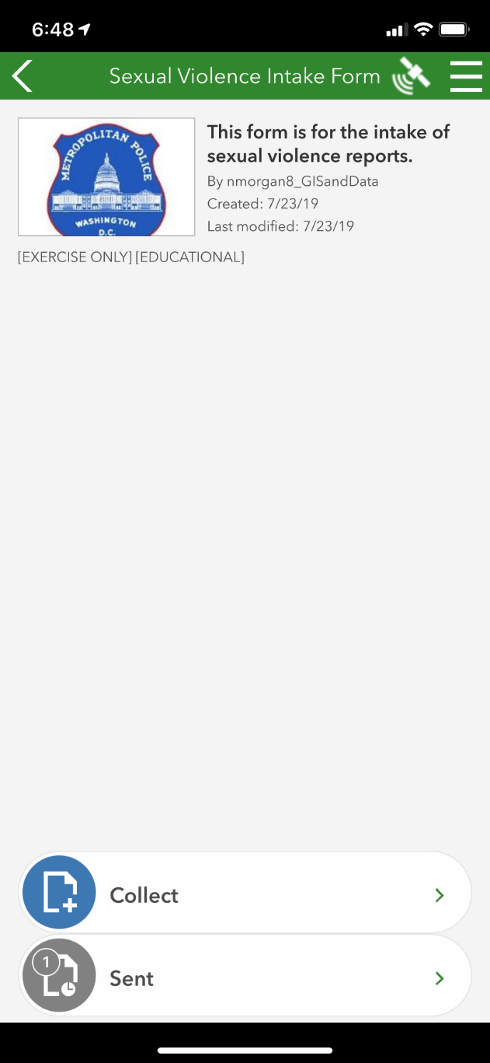

Appendix B: Survey Format in Survey 123 Mobile App

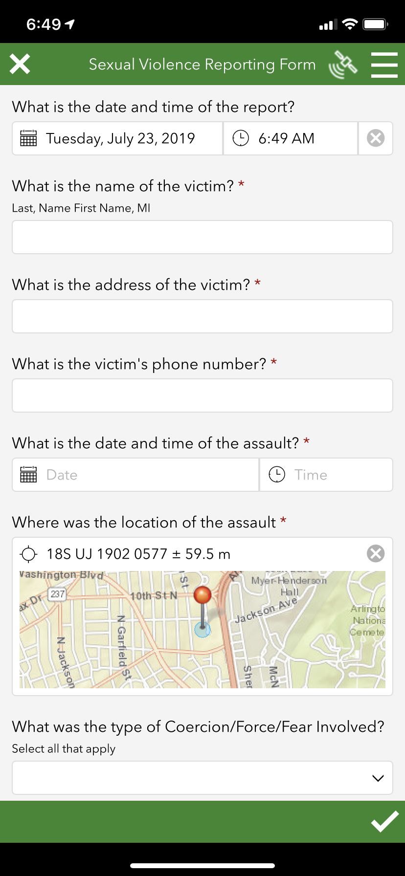

Appendix C: Survey Format on Desktop

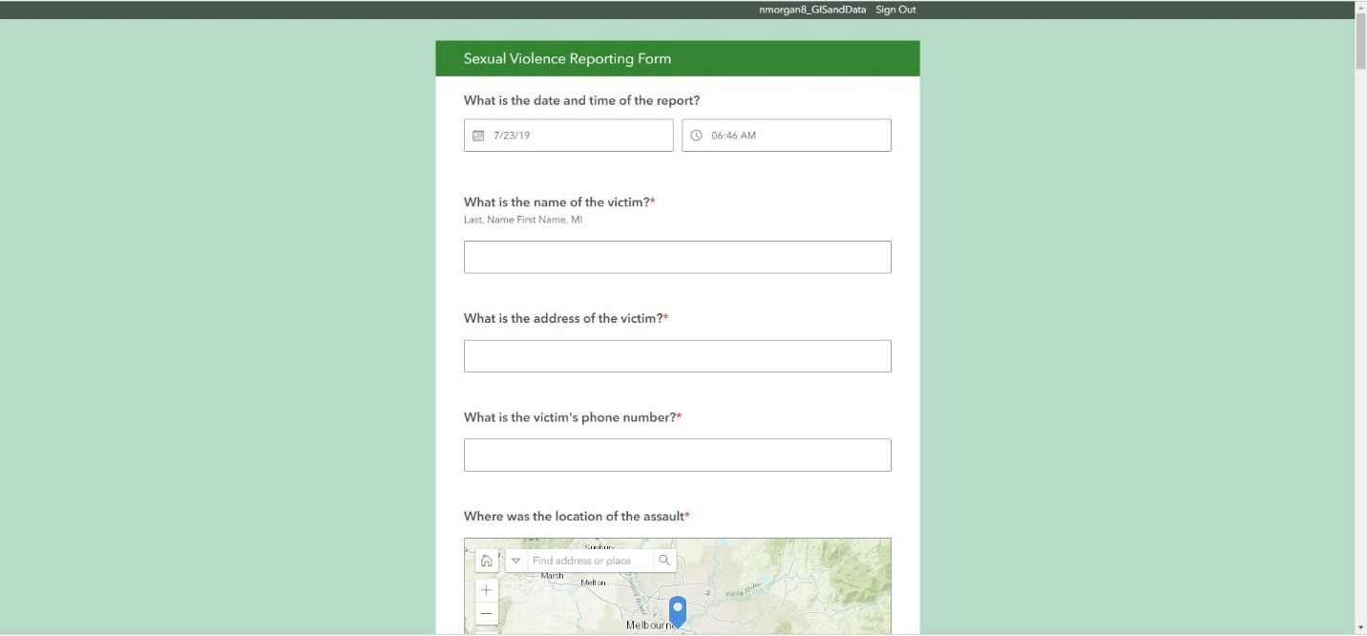

Appendix D: Survey 123 Sexual Violence Intake Form Questions



Appendix E: Sexual Violence by Ward

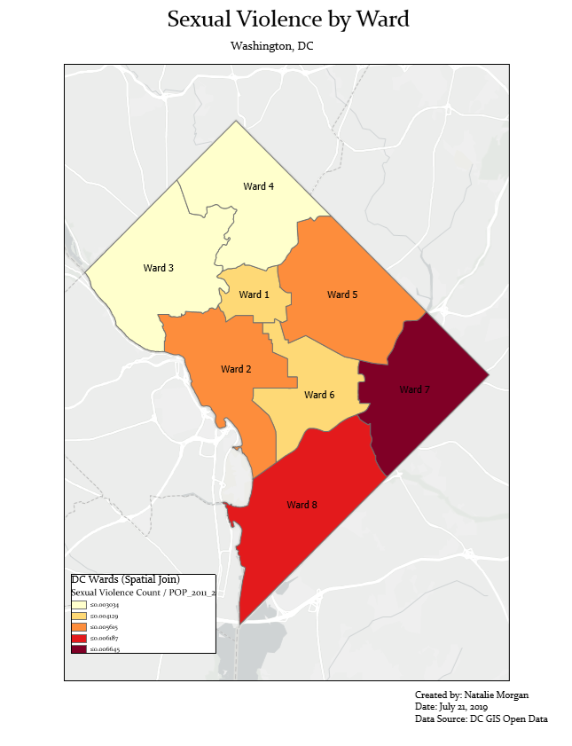

Appendix F: Sexual Violence Trends

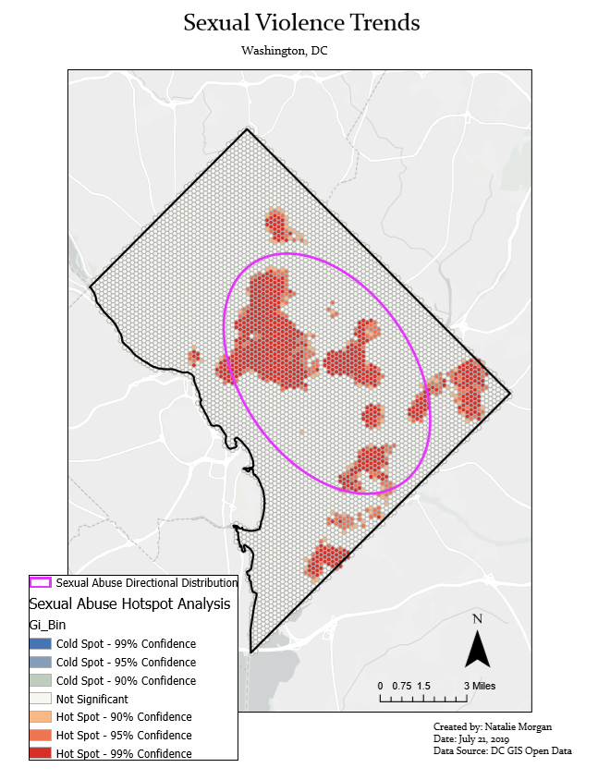

Appendix G: Sexual Violence and Universities

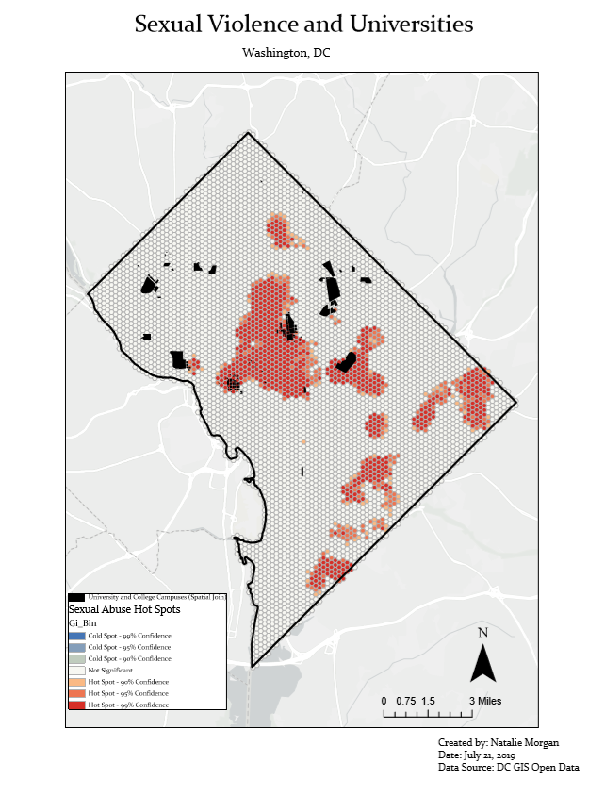

Appendix H: Sexual Violence and Poverty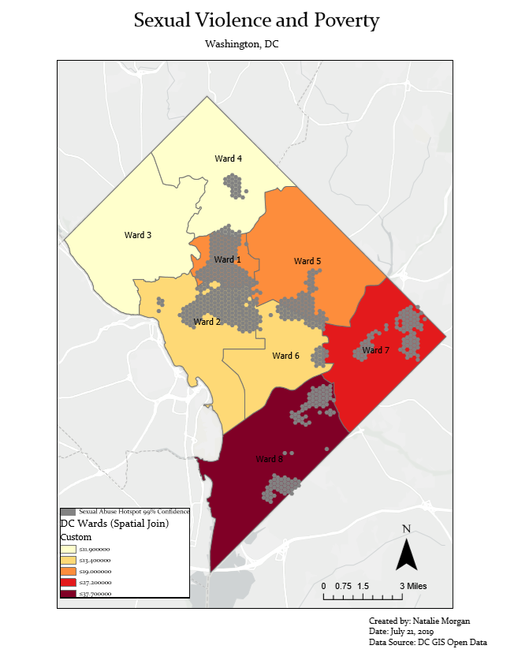Appendix I: Sexual Violence and Race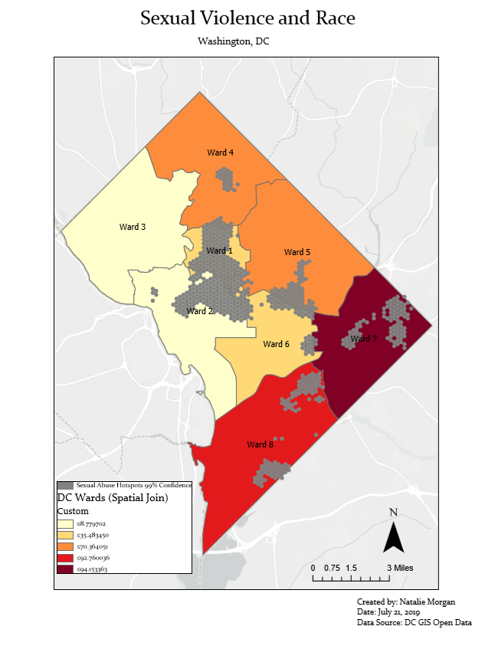

Appendix J: Sexual Violence and Education Level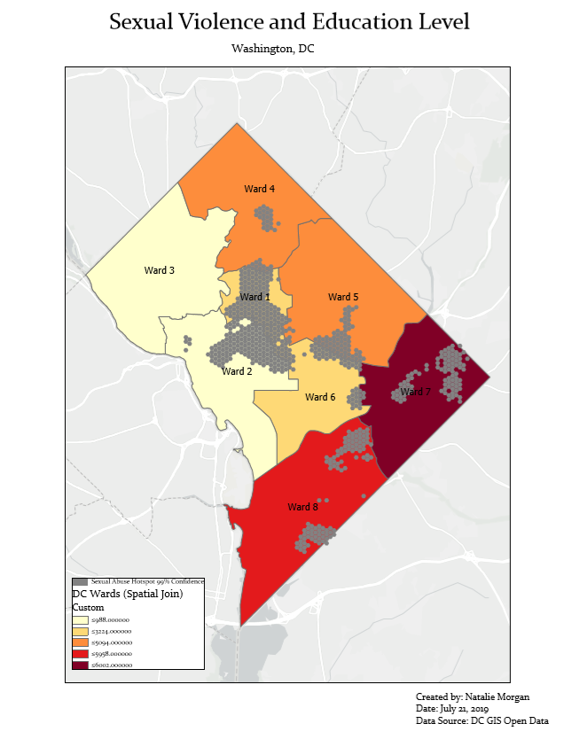

Appendix K: Violent Crime and Sexual Violence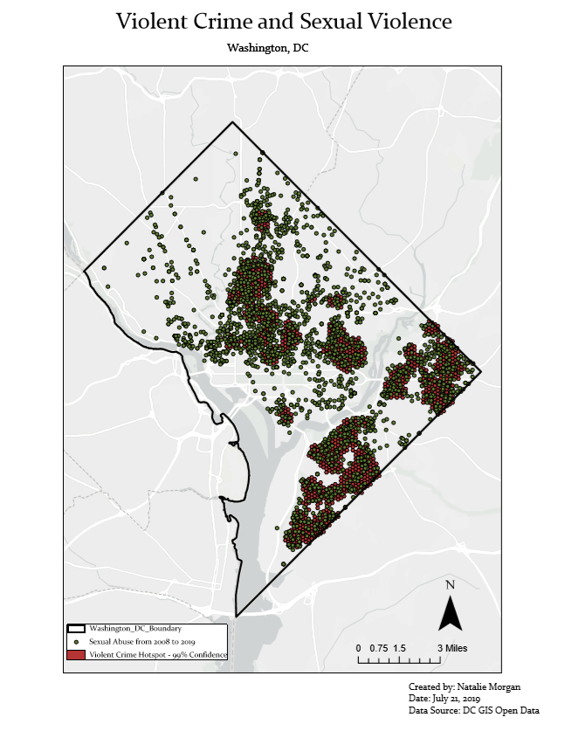

Appendix L: Sexual Violence by Ward

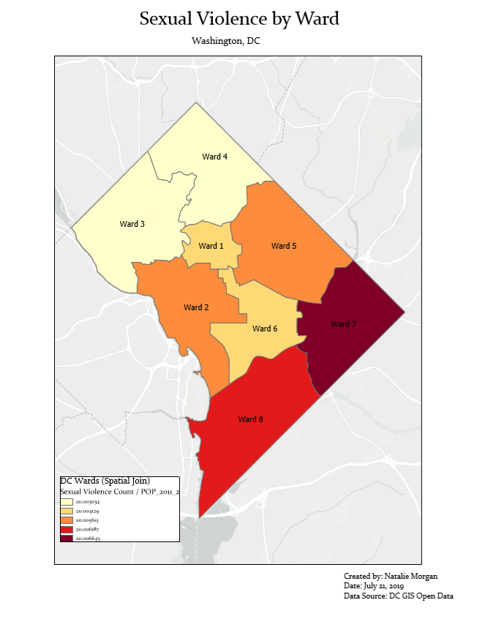

Appendix M: Sexual Violence Counts by University

|  |  |
| --- | --- |
| **University** | **Sexual Violence Count** |
| Howard University | 514 |
| Johns Hopkins University Nitze School of Advanced International Studies | 360 |
| Strayer University | 349 |
| The Institute of World Politics | 346 |
| Gallaudet University | 339 |
| NYU Washington, DC | 316 |
| University of California Washington Center | 311 |
| George Washington University | 259 |
| University of the Potomac | 259 |
| Cornell in Washington | 216 |
| Georgetown Law | 211 |
| ASU in Washington, DC | 205 |
| Catholic University of America | 204 |
| Trinity College | 142 |
| Saint Paul’s College | 107 |
| Dominican House of Studies | 107 |
| Les Aspin Center for Government | 104 |
| Theological College | 104 |
| Capuchin College | 90 |
| Stanford in Washington | 85 |
| Georgetown | 80 |
| Georgetown University | 80 |
| Howard University School of Divinity | 74 |
| Marist College | 25 |
| American University | 55 |
| National Defense University | 53 |
| University of the District of Columbia | 39 |
| American University Washington College of Law | 39 |
| Our Lady of Lebanon Maronite Seminary | 33 |
| Howard University Law School | 25 |
| American University Spring Valley Building | 14 |
| George Washington University at Mount Vernon | 13 |

Appendix N: Sexual Violence and Poverty Counts by Ward

|  |  |  |  |
| --- | --- | --- | --- |
| **Ward** | **Sexual Violence Count** | **Percentage of Sexual Violence by Ward** | **Percentage Below Poverty Line** |
| Ward 8 | 502 | 17.9 | 37.7 |
| Ward 7 | 487 | 17.3 | 27.2 |
| Ward 2 | 436 | 15.5 | 13.4 |
| Ward 5 | 400 | 14.2 | 19 |
| Ward 6 | 348 | 12.3 | 12.5 |
| Ward 1 | 296 | 10.5 | 13.5 |
| Ward 4 | 252 | 9 | 11.9 |
| Ward 3 | 88 | 3.1 | 9.4 |

Appendix O: Sexual Violence and Population Black by Ward

|  |  |  |  |
| --- | --- | --- | --- |
| **Ward** | **Sexual Violence Count** | **Percentage Population Black** | **Percentage Below Poverty Line** |
| Ward 8 | 502 | 92.8 | 37.7 |
| Ward 7 | 487 | 35.5 | 27.2 |
| Ward 2 | 436 | 94.2 | 13.4 |
| Ward 5 | 400 | 8.8 | 19 |
| Ward 6 | 348 | 30.3 | 12.5 |
| Ward 1 | 296 | 7 | 13.5 |
| Ward 4 | 252 | 6.9 | 11.9 |
| Ward 3 | 88 | 56.4 | 9.4 |

Appendix P: Sexual Violence and No High School Diploma by Ward

|  |  |  |  |
| --- | --- | --- | --- |
| **Ward** | **Sexual Violence Count** | **Percentage No High School Diploma** | **Percentage Below Poverty Line** |
| Ward 8 | 502 | 7.2 | 37.7 |
| Ward 7 | 487 | 3.7 | 27.2 |
| Ward 2 | 436 | 8.2 | 13.4 |
| Ward 5 | 400 | 1.3 | 19 |
| Ward 6 | 348 | 3.9 | 12.5 |
| Ward 1 | 296 | 6.2 | 13.5 |
| Ward 4 | 252 | 0.9 | 11.9 |
| Ward 3 | 88 | 4.7 | 9.4 |

Appendix Q: Timeline of Sexual Violence in Washington, DC

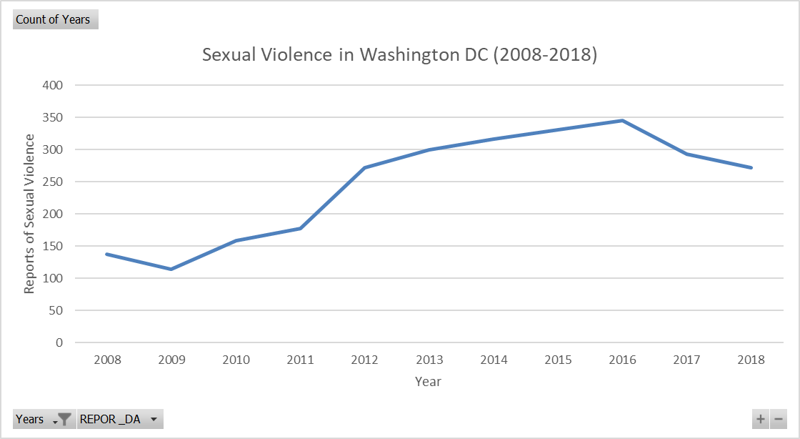

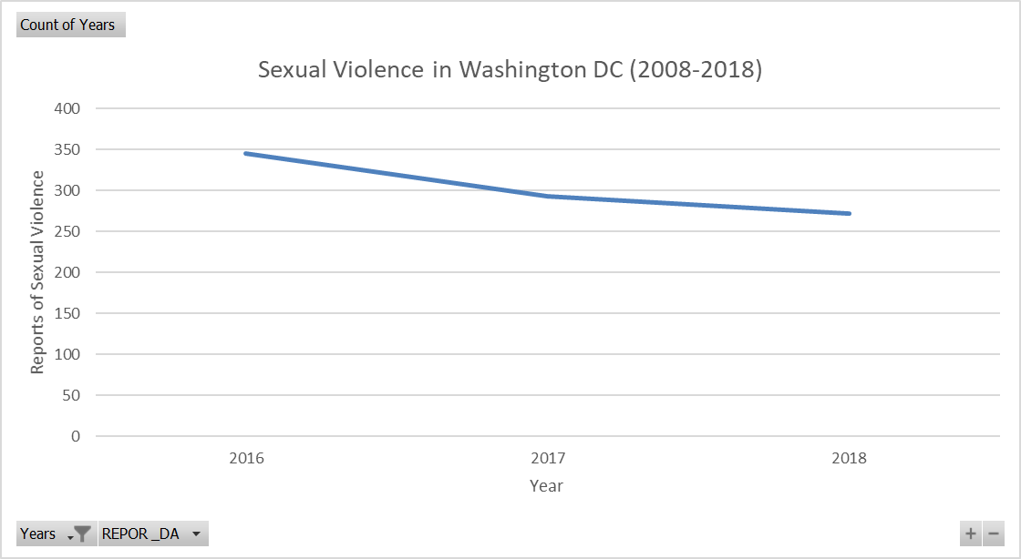

Appendix R: Weblinks to Data Presentation

Survey 123 Form (XLS): <https://services1.arcgis.com/0MSEUqKaxRlEPj5g/arcgis/rest/services/service_723aace85b2d4e838b2bd21da2a53a6a/FeatureServer>

Survey 123 Map: <https://gisanddata.maps.arcgis.com/home/item.html?id=5fd7b9533b794410a1edff5a8cfe9ec5>

Static Maps:

* Sexual Violence by Ward: <https://gisanddata.maps.arcgis.com/sharing/rest/content/items/62d128aff91949c8a65f83b828f4ecbb/data>
* Sexual Violence Trends: <https://gisanddata.maps.arcgis.com/sharing/rest/content/items/f9be71c95a894ee5991238ab61509447/data>
* Sexual Violence and Universities: <https://gisanddata.maps.arcgis.com/sharing/rest/content/items/e9997e25843447d1b300d61531ea33d7/data>
* Violent Crime and Sexual Violence: <https://gisanddata.maps.arcgis.com/sharing/rest/content/items/033cc705b4d14c87967393e504ee3a53/data>
* Sexual Violence and Poverty: <https://gisanddata.maps.arcgis.com/sharing/rest/content/items/9c5bd1b57922424a80560c8b50a6f77c/data>
* Sexual Violence and Race: <https://gisanddata.maps.arcgis.com/sharing/rest/content/items/d39668667c164ed18ca539f95795de70/data>
* Sexual Violence and Education: <https://gisanddata.maps.arcgis.com/sharing/rest/content/items/cea2bb370fdf467aa7f4bf0295d10533/data>

Web Maps:

* Sexual Violence by Washington DC Ward: <https://services1.arcgis.com/0MSEUqKaxRlEPj5g/arcgis/rest/services/Sexual_Violence___No_High_School_Diploma_WFL1/FeatureServer>
* Sexual Violence Trends: <https://gisanddata.maps.arcgis.com/home/item.html?id=27ad3788d9aa4f9282fb9cbfb2f42393>
* Sexual Violence Time Series: <https://gisanddata.maps.arcgis.com/home/item.html?id=96c510a63da94e50adc2e200bc679af2>
* Violent Crime and Sexual Violence: <https://gisanddata.maps.arcgis.com/home/item.html?id=97a052eb427d454abcbf14290d6c7af2>
* Sexual Violence and Universities: <https://gisanddata.maps.arcgis.com/home/item.html?id=91d59ca72ba04372ae0506b5411128ed>
* Sexual Violence and Poverty: <https://gisanddata.maps.arcgis.com/home/item.html?id=57f16cb13ebf43f3a56871790a0f6b46>
* Sexual Violence and Race: <https://gisanddata.maps.arcgis.com/home/item.html?id=dda0e37c2fb140abbe810732c29085ec>
* Sexual Violence and Education: <https://gisanddata.maps.arcgis.com/home/item.html?id=111a10adc17e4c2795989649799c740a>
* Sexual Abuse in Washington DC (Web Mapping Application Base Map): <https://gisanddata.maps.arcgis.com/home/item.html?id=4c70b8101ce541359526f84168d847bd>

Web Map Application (Web App Builder): <https://gisanddata.maps.arcgis.com/apps/webappviewer/index.html?id=d7daee4b4eed42329726ce1f72317e3f>

Story Map: <https://gisanddata.maps.arcgis.com/apps/MapSeries/index.html?appid=d9729ab48d1a413792ee05f96033110e>

Time Series: <https://www.youtube.com/watch?v=BdiTF2mPMMU>

1. Eisman, Quyen, and Kusunoki, “Sexual Violence Victimization among Youth Presenting to an Urban Emergency Department: The Role of Violence Exposure in Predicting Risk,” *Health Education & Behavior* 45, no. 4 (2018): 625.
2. International Associations of Chiefs of Police, “Understanding, Investigating and Responding to Sexual Assault,” *The Community Policing Dispatch* 11 no.4.
3. International Associations of Chiefs of Police, “Understanding.”
4. Metropolitan Police Department, “Sexual Assault Facts and Figures,” Accessed June 20, 2019. <https://mpdc.dc.gov/node/226642>.
5. “Sexual Assault Facts and Figures.”
6. “Sexual Assault Facts and Figures.”
7. “Sexual Assault Facts and Figures.”
8. Johnson, “Why Doesn’t She Just Report It?: Apprehensions and Contradictions for Women Who Report Sexual Violence to the Police,” *Canadian Journal of Women and the Law* 29, no.1 (2017): 37.
9. Johnson, “Why Doesn’t She Just Report It?,” 52.
10. Johnson, “Why Doesn’t She Just Report It?,” 52.
11. Johnson, “Why Doesn’t She Just Report It?,” 51.
12. Johnson, “Why Doesn’t She Just Report It?,” 59.
13. Johnson, “Why Doesn’t She Just Report It?,” 40.
14. Johnson, “Why Doesn’t She Just Report It?,” 43.
15. Johnson, “Why Doesn’t She Just Report It?,” 38.
16. Johnson, “Why Doesn’t She Just Report It?,” 41.
17. Eisman et al., “Sexual Violence Victimization,” 625.
18. Eisman et al., “Sexual Violence Victimization,” 632.
19. Eisman et al., “Sexual Violence Victimization,” 626.
20. Pennamon, “Rethinking Sexual Violence Reporting,” *Diverse Issues in Higher Education* 34 no. 15 (2017), 11.
21. United States Government Accountability Office, *Sexual Violence Data: Actions Needed to Improve Clarity and Address Differences across Federal Data Collection Efforts: Report to Ranking Member, Permanent Subcommittee on Investigations, Committee on Homeland Security and Governmental Affairs*, (Washington DC, U.S. Senate), 33.
22. United States Government Accountability Office, *Sexual Violence Data,* Introduction and 15.
23. United States Government Accountability Office, *Sexual Violence Data*, 15.
24. United States Government Accountability Office, *Sexual Violence Data*, 19.
25. United States Government Accountability Office, *Sexual Violence Data*, 12.
26. Chainey, Spencer, and Ratcliffe, *GIS and Crime Mapping,* (Chichester, Wiley, 2005), 116.
27. Chainey et al., *GIS and Crime Mapping*, 106.
28. Chainey et al., *GIS and Crime Mapping*, 106.
29. Chainey et al., *GIS and Crime Mapping*, 96.
30. Chainey et al., *GIS and Crime* Mapping, 90.
31. Elmes, Conley, and Roedel, *Forensic GIS: The Role of Geospatial Technologies for Investigating Crime and Providing Evidence*, (Dordrecht, Springer, 2014), 22.
32. Elmes et al., *Forensic GIS*, 25.
33. Elmes et al., *Forensic GIS*, 22.
34. Elmes et al., *Forensic GIS*, 14, 20.
35. Chainey et al., *GIS and Crime Mapping*, 309.
36. Metropolitan Police Department, “Crime Cards,” Accessed June 19, 2019. <https://dcatlas.dc.gov/crimecards/> .
37. Johnson, “Why Doesn’t She Just Report It?,” 37.
38. Johnson, “Why Doesn’t She Just Report It?,” 37.
39. Pennamon, “Rethinking Sexual Violence Reporting,” *11*.
40. Jung, Sandy, “Sexual Violence Risk Prediction in a Police Context,” *Sexual Abuse: A Journal of Research and Treatment* 30 no. 5 (2018), 577.
41. DC GIS Open Data, *Ward from 2012*, V1 (November 30, 2017), distributed by Open Data DC, <https://opendata.dc.gov/datasets/ward-from-2012>.
42. DC GIS Open Data, *University and College Campuses*, V1 (June 14, 2018), distributed by Open Data DC, <https://opendata.dc.gov/datasets/university-and-college-campuses>.
43. DC GIS Open Data, *Ward from 2012*.
44. Lewis, Aidan and Bill McKenna, “Washington DC from murder capital to boomtown,” August 6, 2014, Accessed July 24, 2019. <https://www.bbc.com/news/magazine-28605215>.
45. DC GIS Open Data, *Crime Incidents* [see works cited for information on each of the 11 annual datasets].
46. “Crime Cards”
47. “Crime Cards”
48. DC GIS Open Data, *Ward from 2012*.
49. DC GIS Open Data, *University and College Campuses*.
50. DC GIS Open Data, *Washington DC Boundary*, V1 (July 3, 2013), distributed by Open Data DC, <https://opendata.dc.gov/datasets/washington-dc-boundary>.
51. Elmes et al., *Forensic GIS*, 11.
52. Elmes et al., *Forensic GIS*, 14.
53. International Association of Chiefs of Police, “Sexual Assault Supplemental Report Form,” Accessed June 19, 2019. <https://www.theiacp.org/resources/document/sexual-assault-supplemental-report-form>.
54. International Associations of Chiefs of Police, “Understanding.”
55. DC GIS Open Data, *Crime Incidents*.
56. DC GIS Open Data, *Ward from 2012*.
57. DC GIS Open Data, *Washington DC Boundary*.
58. Esri, “Why Hexagons?,” Accessed June 19, 2019, 2019. <https://pro.arcgis.com/en/pro-app/tool-reference/spatial-statistics/h-whyhexagons.htm>.
59. Chainey et al., *GIS and Crime Mapping*, 123.
60. DC GIS Open Data, *University and College Campuses*.
61. DC GIS Open Data, *Crime Incidents.*
62. Pennamon, “Rethinking Sexual Violence Reporting,” 12.
63. Johnson, “Why Doesn’t She Just Report It?,” 37.